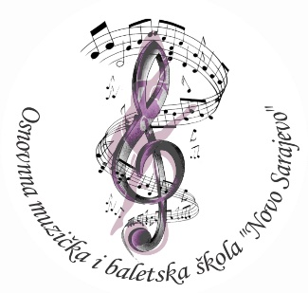**JU Osnovna muzička i baletska škola ID: 4200163610004**

**‘’Novo Sarajevo’’ Tel: 033/ 710-860; 033/651-523**

**Kemala Kapetanovića 43 Mail: ombsns@gmail.com**

**71000 Sarajevo, BiH**

I Z J A V A

JA, RODITELJ/STARATELJ _______________________________________________________

UČENIKA _____________________________________________ OVIM PUTEM PRAVDAM

IZOSTANKE MOG DJETETA ZA PERIOD OD: _______________ DO: ______________________

DIJETE JE IZOSTALO IZ SLJEDEĆIH RAZLOGA (navesti razlog): ____________________________________________________________________________

____________________________________________________________________________

____________________________________________________________________________

KONTAKT RODITELJA:

Tel.: _____________________

e-mail:___________________

Adresa: __________________

IME I PREZIME RODITELJA/STARATELJA I POTPIS

1. _______________________________
2. _______________________________